**AIM**

Create a table customer with the following fields: customerid, name, branch, accno, balance. Customerid is the primary key. In all other fields, we cannot enter null value. The balance should not be less than 500.

SQL> CREATE TABLE customer (customerid INT PRIMARY KEY, name VARCHAR(20) NOT NULL, branch VARCHAR(20) NOT NULL, accno INT NOT NULL, balance INT NOT NULL CHECK (balance >= 500));

Name Null? Type

-------------------------------- ------------------ --------------------

CUSTOMERID NOT NULL NUMBER(38)

NAME NOT NULL VARCHAR2(20)

BRANCH NOT NULL VARCHAR2(20)

ACCNO NOT NULL NUMBER(38)

BALANCE NOT NULL NUMBER(38)

a.       Find out the details of all customers whose balance is between 2000 and 3000.

b.      Show all branches of the bank (duplicates eliminated).

c.       Find out the details of all customers whose branch is kottayam and balance>5000.

d.      Show the details of all customers whose name start with A.

e.       Retrieve the branch name values as city.

f.        Find the total balance of the bank.

g.      Find the average balance of the bank.

h.      Find the max value for balance.

i.        Find the min balance of the bank.

j.        Count number of records in the table.

k.      Modify the size of name in the table to 50

l.        Add a new column address to the table with data type varchar(10) and insert values into it.

A)

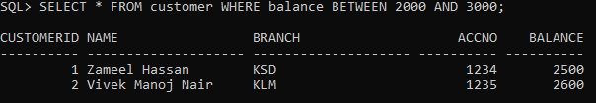

B)

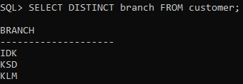

C)

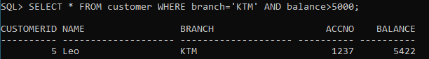

D)

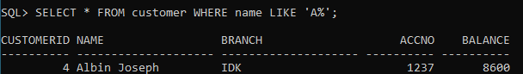

E)

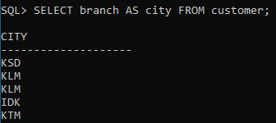

F)

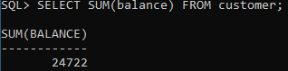

G)

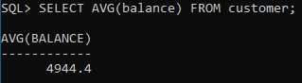

H)

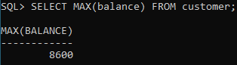

I)

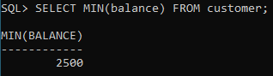

J)

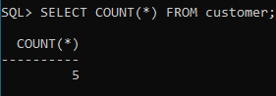

K)



L)



